UNIVERSITY OF ENGINEERING AND TECHNOLOGY, LAHORE
(NAROWAL CAMPUS)

NAME :
ABDULAHAD HUSSAIN
ROLL NO. :
549
SECTION:
A
SUBJECT:
OBJECT ORIENTED PROGRAMMING(OOP)
SUBMITTED TO:
MAM SADIA TARIQ
LAB MANNUAL
LAB #02:
Problem No. 01:
Statement:
1D Dynamic array using pointer
Source Code:
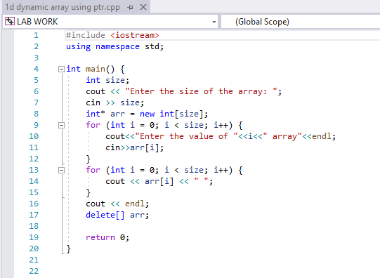
Output:
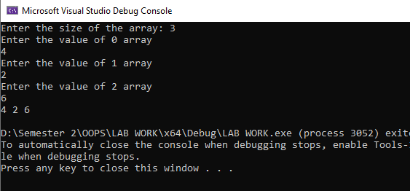
Problem No. 02:
Statement:
2D Dynamic array using double pointer
Source code:
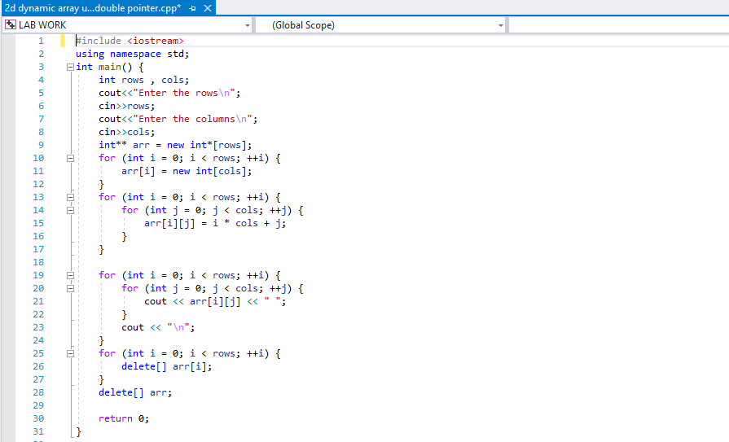
Output:
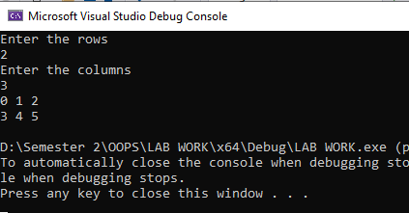
Problem No. 03:
Statement:
Daggling Pointer
Source Code:
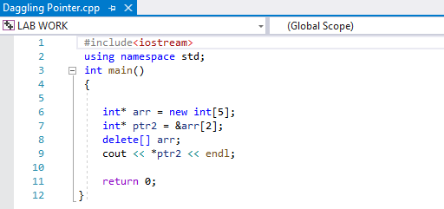
Output:
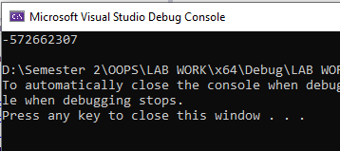

Problem No. 4:
Statement:
Memory leak
Source Code:
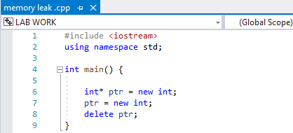
Problem No. 5:
Statement:
Reverse number using recursive function
Source Code:
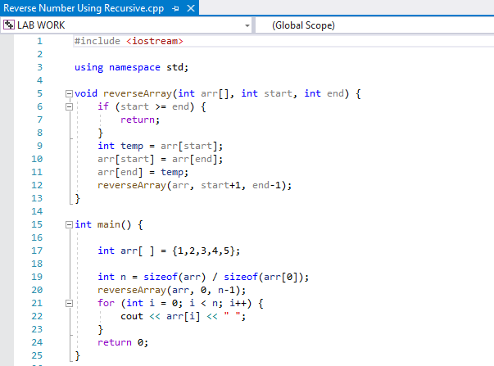
Output:
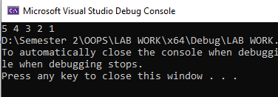
Problem No. 6:
Statement:
Structure
Source Code:
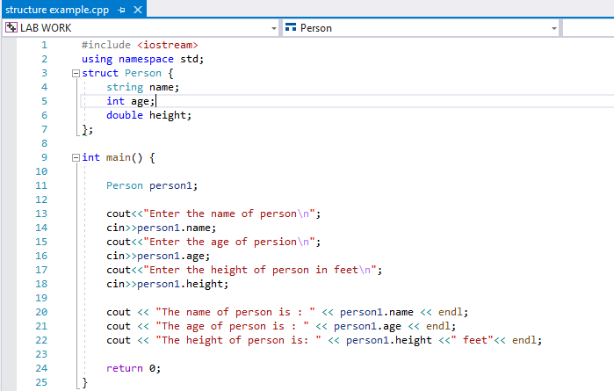
Output:
